



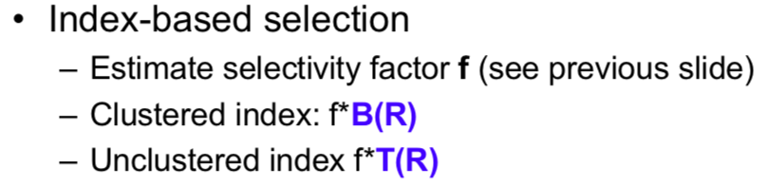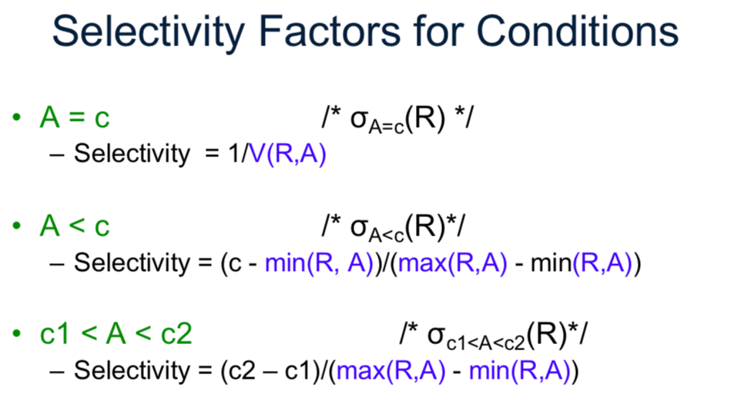

In multiway relationships, and arrow pointing into an entity set E means that if we select one entity from each of the other entity sets in the relationship, those entities are related to at most one entity in E.

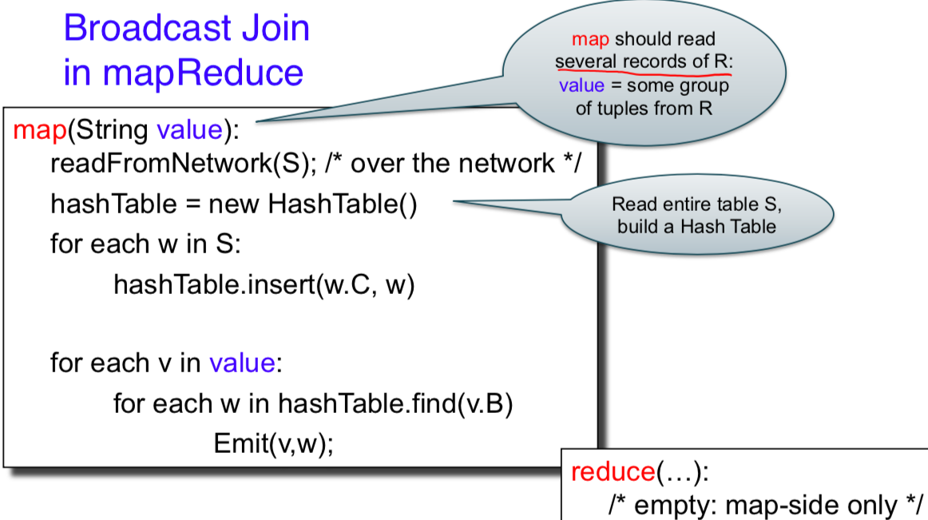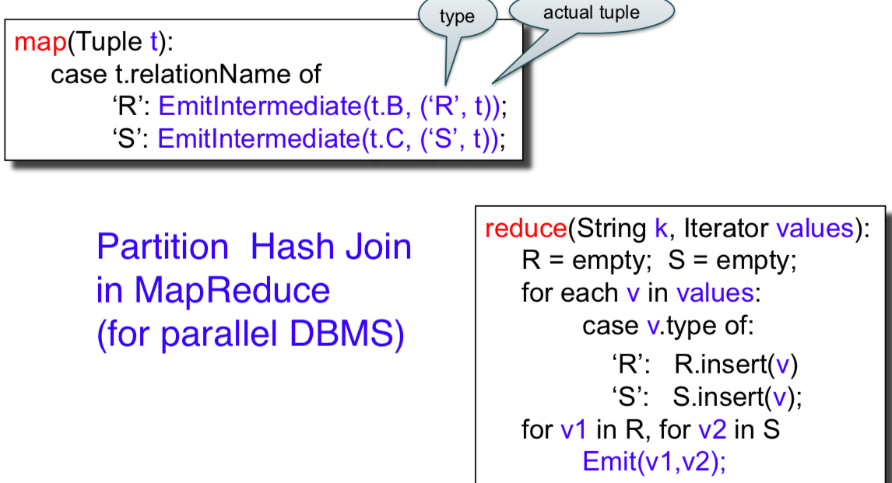

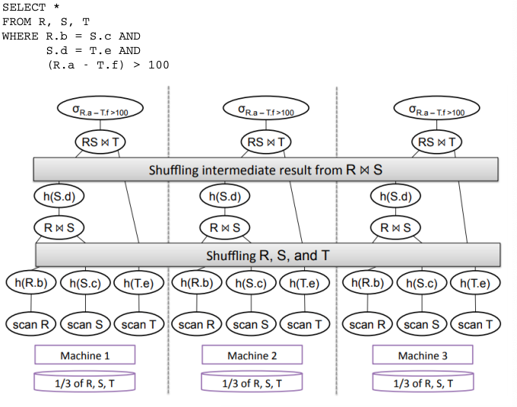

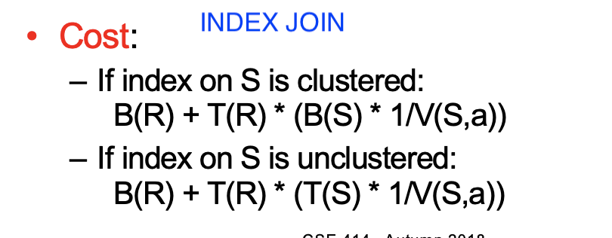

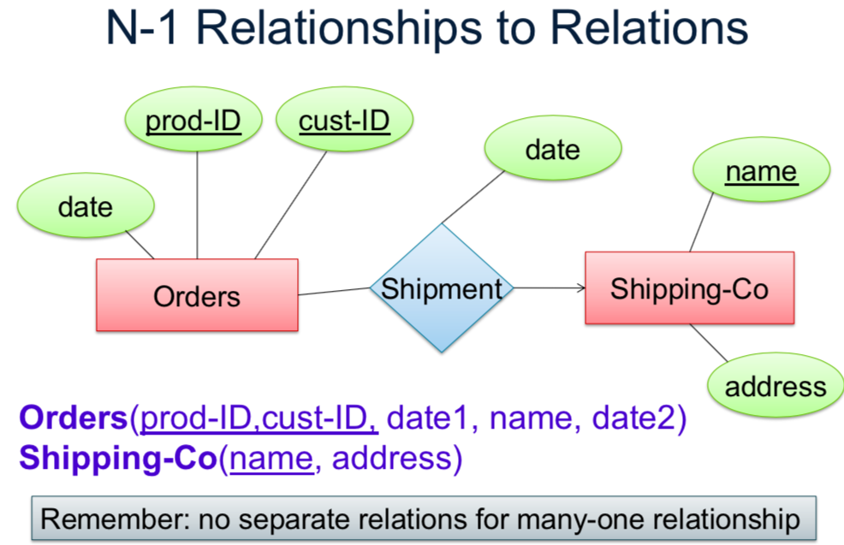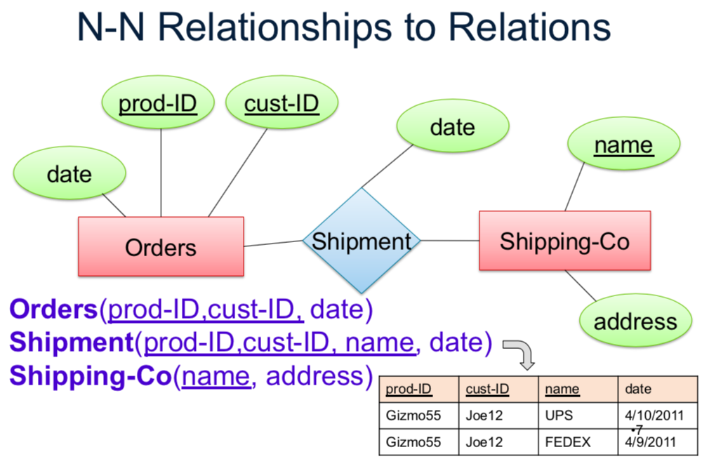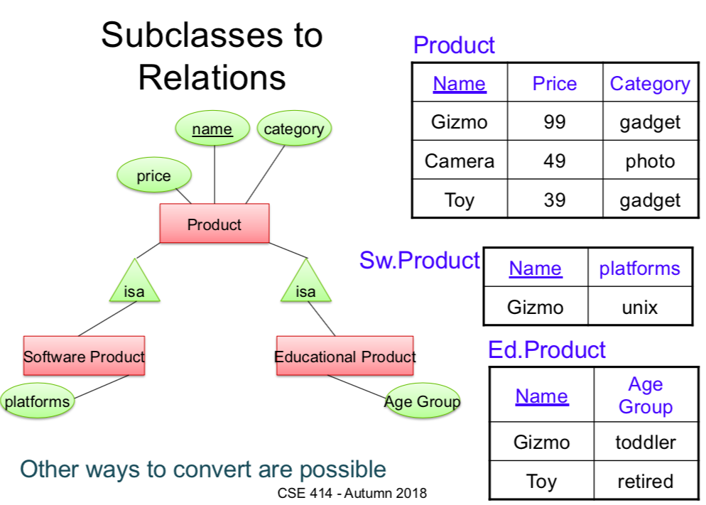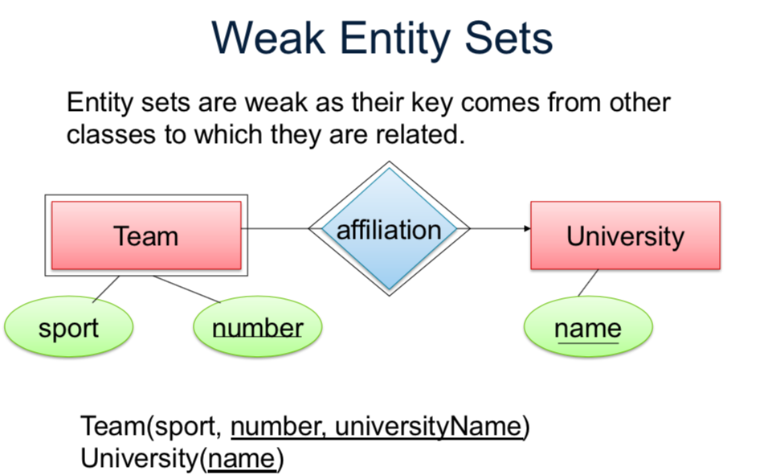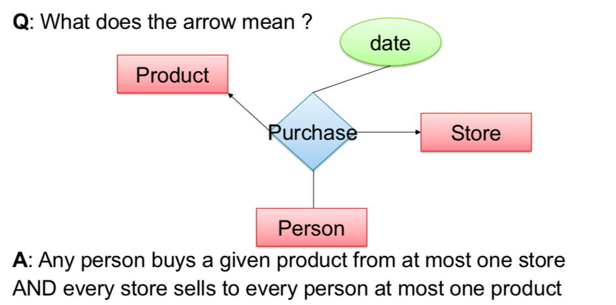

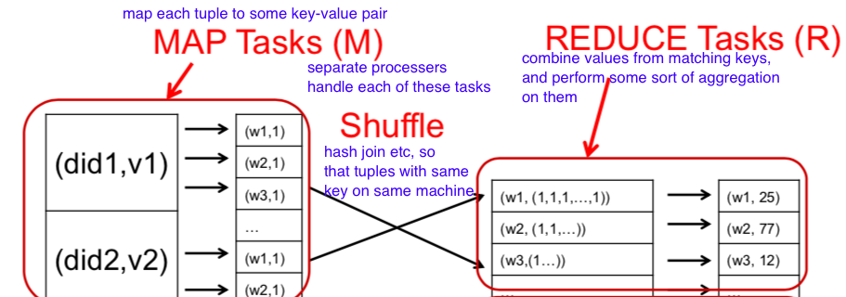

Map reduce handles failure by writing intermediate results to disk. Stragglers (slower than normal processes) are handled by assigning a task to multiple workers/processors. If one finishes before other, it starts at next task. Extraneous processes killed once process completes once.

**Spark** writes intermediate results to **main memory** to help prevent slow-down due to file writing in mapReduce. If server fails, RDD is lost but can be recomputed based on execution plan

**Eager Process**: executes immediately and forces preceeding processes to run as well (count, reduce, save, collect, ACTIONS)

**Lazy Process**: operator tree (similar to RA) created to optimize (map, join, filter, …, TRANSFORMATIONS)

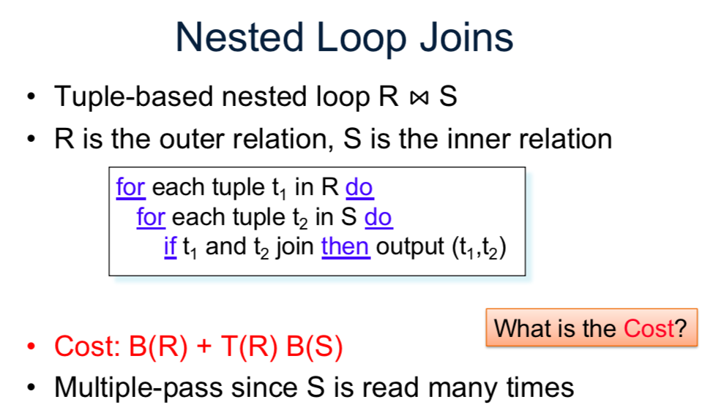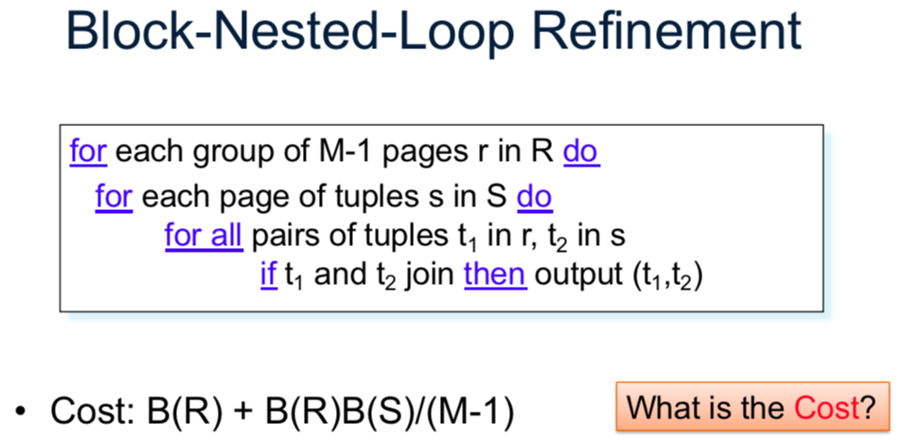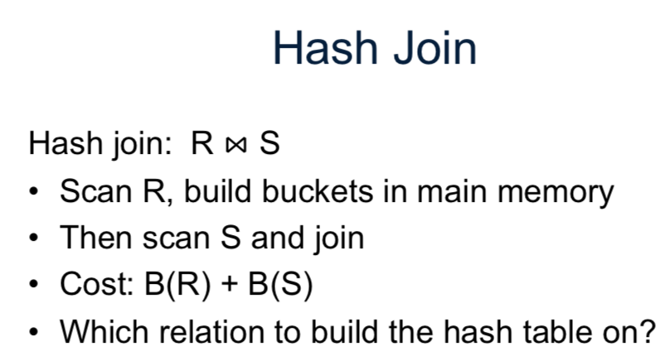

**Constraints**

**Keys**: certain values are unique in tuples

Defined when creating table

**Single-value (relationships):** many to one or one to many relations are maintained.

**Referential**: If table A has a foreign key to B, that key must be present in B

Other: (tuple or attribute level constraints) i.e.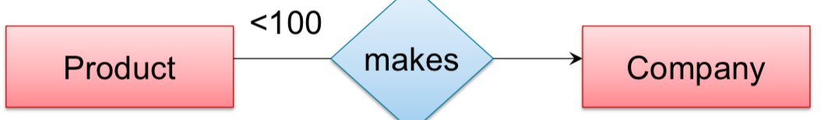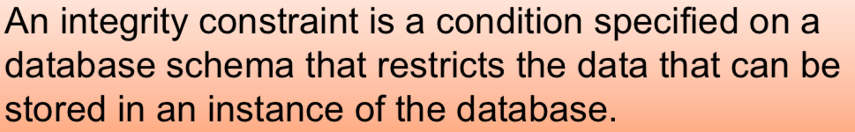

Maintaining referential integrity after data change

(i.e. if I try to delete the key in B that table A references, what happens?)

**NO ACTION:** reject change

**CASCADE:** make deletion, and delete all tuples that are now in violation of referential constraints (i.e. all tuples in A that reference the key in B I just deleted.) If this new deletion created an issue, repeat!

**SET NULL/DEFAULT:** replace missing foreign key with Null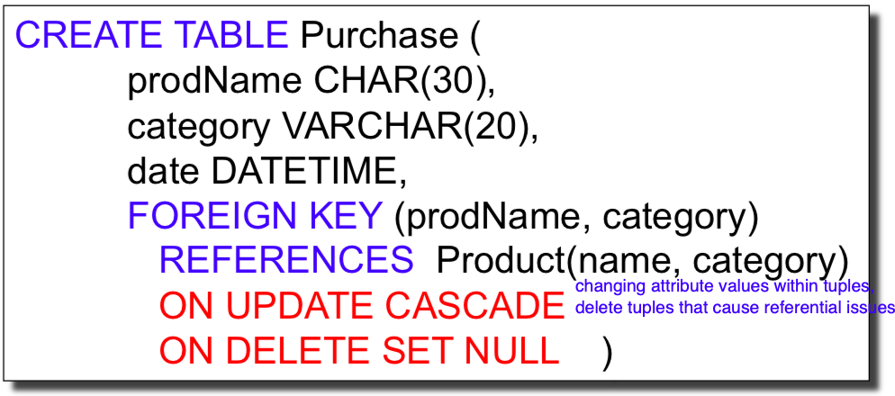

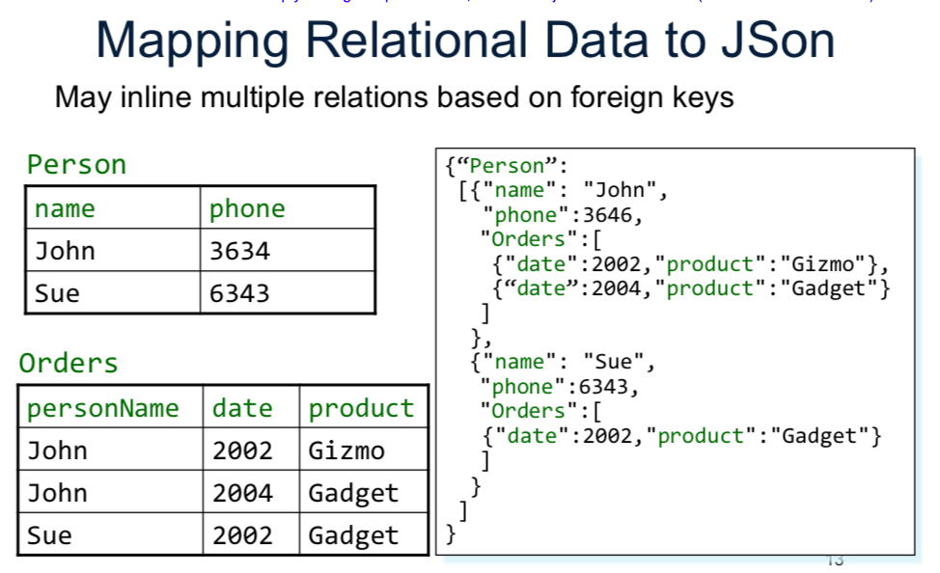

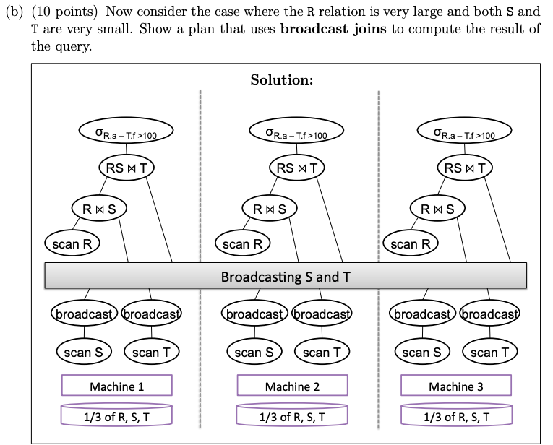



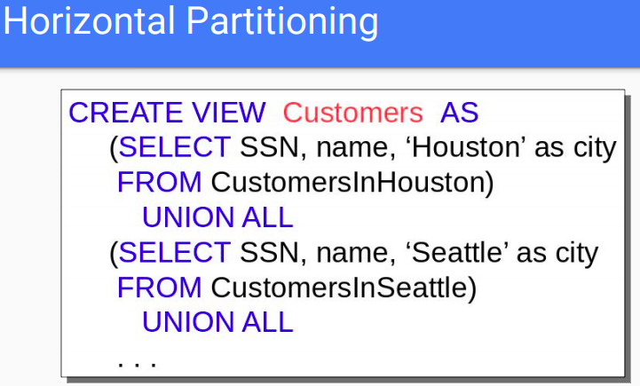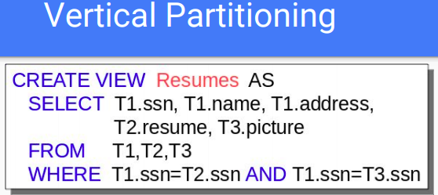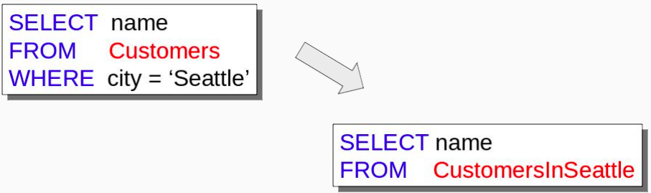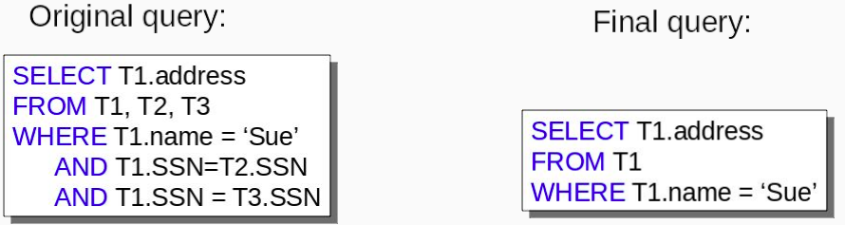

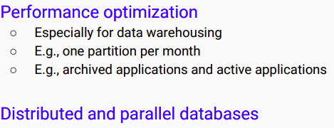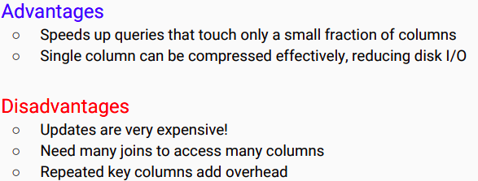

i.e. if I vertically partition, I can fit more tuples on a single block (although attributes spread out further). So if I only need to access a few attributes, it requires a lot less disk reads (less blocks)

Horizontally partition: data can be chosen to be categorized, making it efficient for certain queries

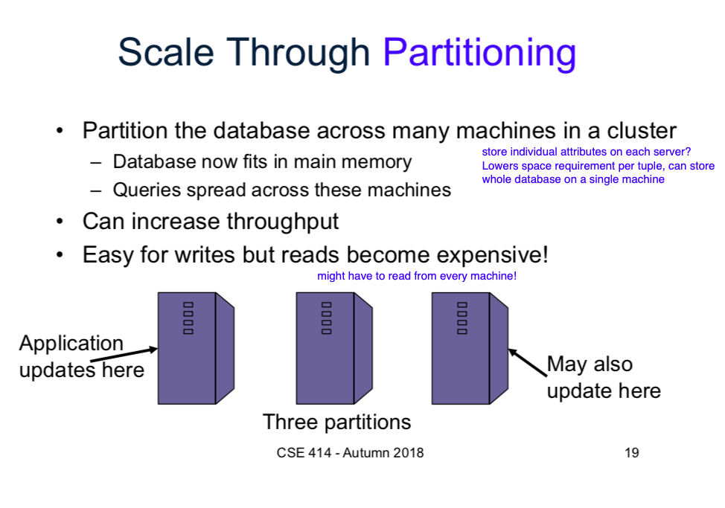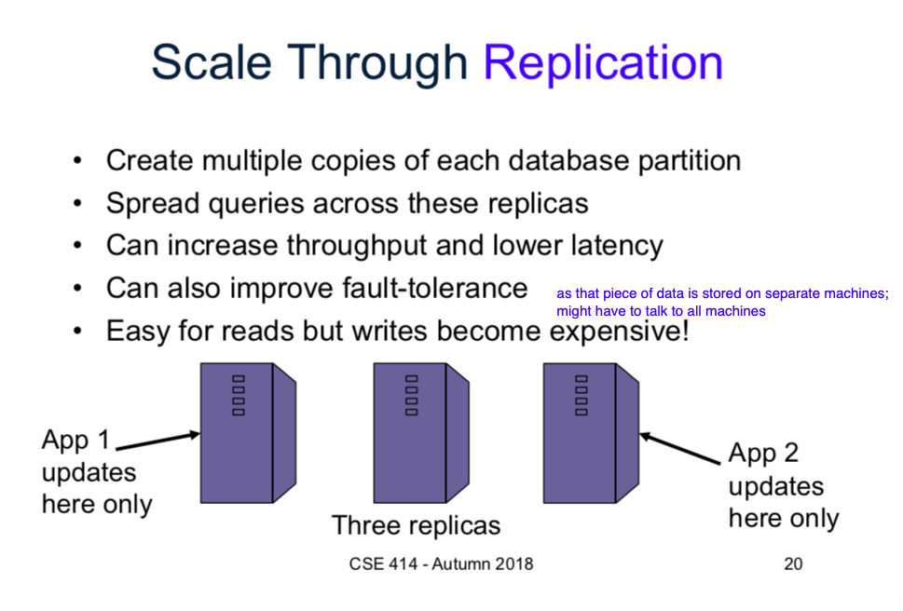

**Transactions**





**Serial schedule:** transactions run one after next; no interweaving; slow

**Serializable schedule:** produces same output to users as serial schedule would; end state of DB same as running transactions serially (hard to check)

**Conflict serializable:** can transform schedule into serial schedule by swapping adjacent non-conflicting elements. Conflict serializable implies serializable but not vice versa. Conflicts: RW, WR, WW to same element by different transactions

**Locking -** generating serializable schedules

We have choice on what to lock: Database? Table, Tuple? Attribute?

**2PL :** in every transaction, all locks precede all unlocks; ensures conflict serializability**, but not recoverability**

**Recoverable =** one transaction can rollback without overwriting work of another

**Strict 2PL:** all locks are held until commit/rollback; ensures conflict serializable AND recoverable

Other problems:

**Phantom Problem:** tuples inserted/deleted; invisible during part of transaction BUT not invisible during entirety of T.

**Deadlocks:** T1 is waiting for element locked by T2, T2 is waiting for an element locked by T3, T3 is waiting for element locked by T1. Waiting cycle

Check for “waiting cycles” periodically; abort some T if found.

Partial Solution =

Shared lock (for reads); other reads can still obtain lock

Exclusive lock (for writes): no other locks allowed

CANNOT obtain write lock if read locks present!



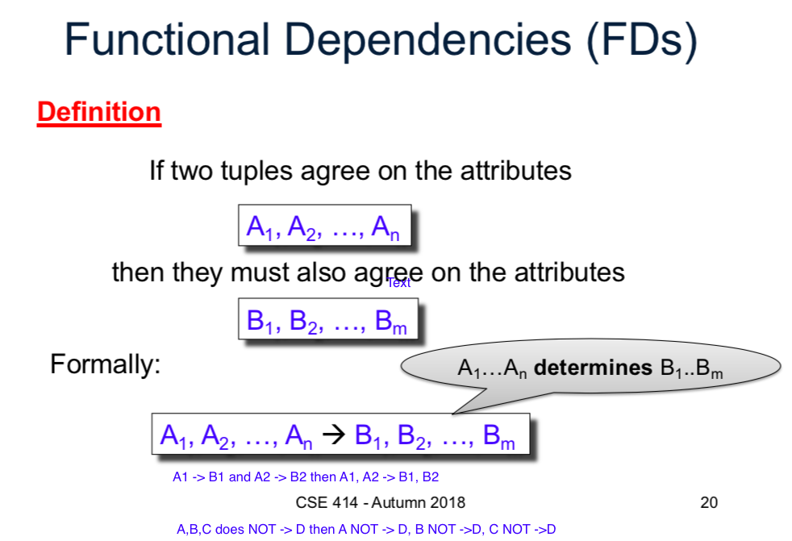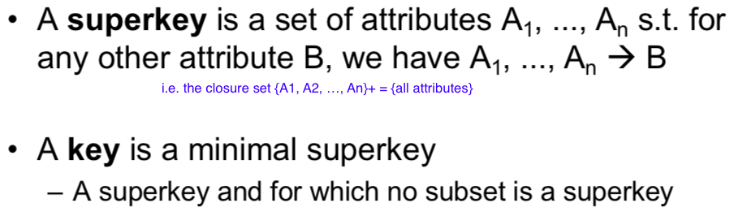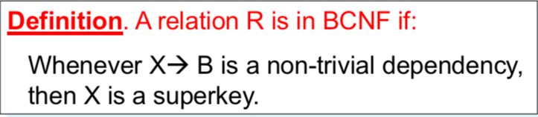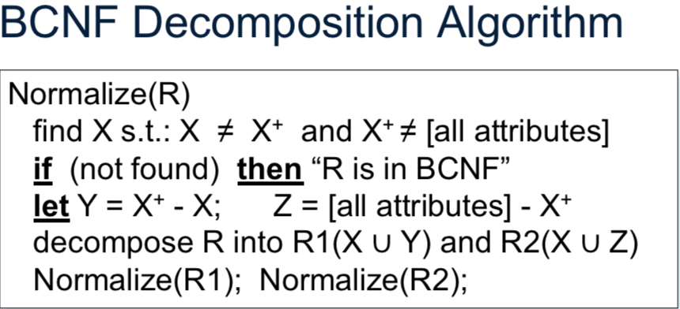

**Lossless Decomposition:** R = S1 natural join S2 natural join …

When you break table into two, the table that keeps the functional dependency A -> B, A becomes the key. For the other table, everything is a key.

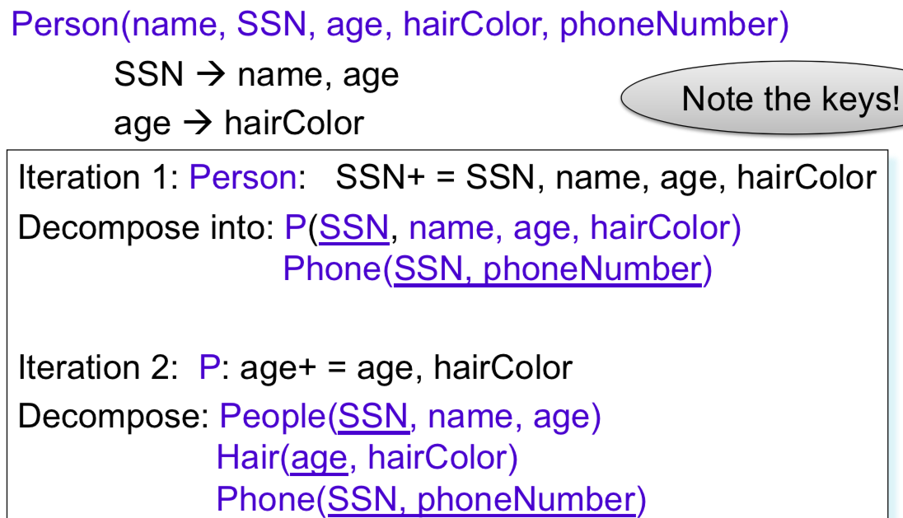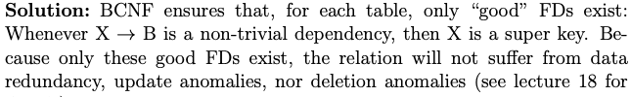

Update/delete anomaly: if you have repeated data, trying to change/delete a single tuples value may not be properly carry over to all instances of that repeated data

SQL tips

* to check if two values are BOTH present in a given attribute, you will need two separate copies of the table.

i.e. find people who like both heineken AND bud light

SELECT P.name

FROM Person P, Likes x, Likes y

WHERE P.name = x.name AND P.name = y.name AND x.beer = heineken AND y.beer = ‘bud light’

Count(*) will count NULL values (counts # of tuples); use count(attribute) instead (likely with an outer join) if trying to get zero counts

FOREIGN KEY (x) references table(y)

PRIMARY KEY (Y)

PRIMARY KEY (X, Y)

**Random Facts**

SQL and RA can express exactly the same class of queries

**physical data independence** = tables do not dictate how information is stored on a disk, only structure of data (i.e. more abstract)

*must be nested with universal qualifier or negation, and most aggregates

CREATE [UNIQUE/UNCLUSTER/CLUSTERED] INDEX indexName ON TableName(attr1, attr2,…) TYPE BTREE

* Index is own separate file
* **Clustered = file is sorted on index attribute**

**CREATE TYPE personType AS CLOSED/OPEN { name : string, phone : [string], email: string?}**

**Scale up vertically:** give more memory/processing power to single nodes; diminishing returns

**Scale up horizontally:** create more machines (makes communication/coordination harder)

NoSQL: Relational model does not work well with parallelism due to structure -> move to semi-structured model: + flexibility, scalability, availability BUT – OLAP, constistency (inconsistent data states big issue)

* Collections (Lists/arrays) can have mixed data types!

**Datalog (RECURSION!)**

Fixpoint semantics; keep applying recursive rule until no more tuples were added last iteration

Fact: Data you put in table

Rule: query

EDB: relations defined in DB

IDB: relations defined in queries (locally)

Head Atom + Atom + Atom = Body

Q2(x,y) :- Actor(x,z), Actor(b,a), Money(x).

Aggregates: name(z), m = min x : {Actor(z,x), male(z)}

Groups By z, aggregates over x

Safe datalog: every negated variable is present in at least one positive atom

Stratified: no rule is added to after being negated/aggregated

